Smart parking in IOT
Phase 2

INTRODUCTION: Phase 2 project
The introduction of smart parking systems in IoT (Internet of Things) involves using sensors, connectivity, and data analytics to optimize the parking experience. Smart parking is a parking strategy that combines technology and human innovation in an effort to use as few resources as possible such as fuel,time and space to achieve faster,easier and denser parking of vehicles for the majority of time they remain idle.
Here few steps ,
1 . Sensor Deployment: Smart parking systems use various sensors, such as ultrasonic, infrared, or magnetic sensors, to detect the presence of vehicles in parking spaces. These sensors are installed in individual parking spots.
2. Data Collection: The sensors collect real-time data on the availability and occupancy of parking spaces. This data is sent to a central server via a wireless network, often using protocols like MQTT or HTTP.
3. User Interface: Users can access this information through dedicated mobile apps, websites, or even electronic displays in the parking lot. They can check the availability of parking spaces before arriving at their destinationn.
Innovation
Smart parking systems in IoT (Internet of Things) revolutionize traditional parking methods by using interconnected devices and data analytics to optimize parking space utilization, enhance user experience, and reduce congestion. These systems typically consist of sensors, cameras, and a cloud-based platform that work together to offer real-time parking information and various benefits:
1. Sensor Deployment: IoT-enabled parking lots are equipped with sensors that detect the presence or absence of vehicles in each parking space. These sensors can be embedded in the pavement or attached to individual parking spots.
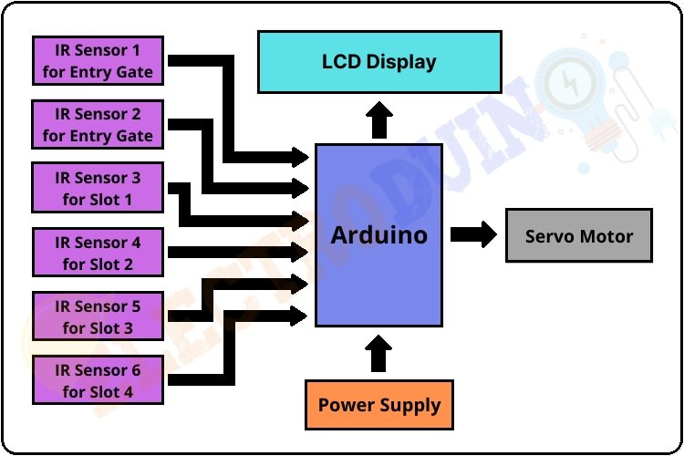
2. Data Collection: The sensors continuously collect data about parking space occupancy, which is then transmitted to a central server or cloud-based platform.
3. Traffic Management: IoT-enabled parking can contribute to improved traffic management by reducing congestion. When drivers can quickly find parking spaces, it reduces the need for circling and searching, which can alleviate traffic.
4 . Energy Efficiency: Smart parking systems can help conserve energy by dimming or turning off lighting and ventilation in unoccupied areas. This not only reduces energy costs but also contributes to sustainability efforts.
5. Analytics and Insights: The data collected by IoT sensors can be a
6. Maintenance Alerts: Sensors can also detect issues such as malfunctioning equipment or blocked parking spaces, enabling maintenance teams to respond promptly and ensure a smooth parking experience.
7. User Experience: Smart parking systems enhance user experience by reducing the stress and frustration associated with finding parking. They provide a convenient and seamless parking process.
8 . Scalability: IoT-based parking solutions are scalable, allowing cities and organizations to expand and adapt their parking infrastructure as needed.
Merits
* Iot sensor can monitoring parking space occupancy in real time allowing
drivers to quickly find available parts .
*. Efficient parking can lead less circling and reduce traffic congestion and resulting in lower fuel consumption and emission.
* Smart parking system can optimise resource allocation and potentially reducing operational costs for urban planning and resource planning.
* Minimize carbon footprint.
* Save time ,gas and money

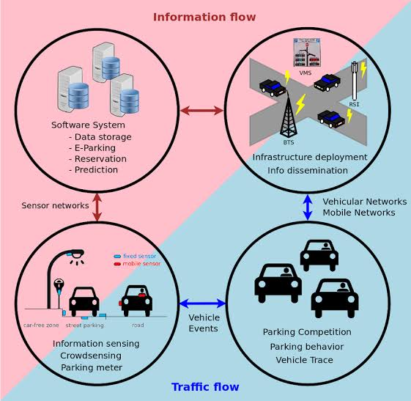

Demerits
* Implementing IoT-based smart parking can be expensive. Setting up sensors, cameras, and a centralized system requires a significant upfront investment.
* The technology involved can be complex, leading to potential technical challenges in installation, maintenance, and troubleshooting.
* IoT devices can sometimes be prone to failures or connectivity issues, which can result in inaccurate data or disruptions in the parking system.
* Smart parking systems often collect data about vehicles and drivers, raising concerns about privacy and data security. Unauthorized access to this data could lead to privacy breaches.
* These systems heavily rely on a stable internet connection. In areas with poor connectivity, the system's effectiveness can be compromised.
* Some users may face difficulties with smartphone apps or other digital interfaces required for smart parking systems, limiting accessibility.

Application
*. IoT sensors can monitor parking spaces and provide real-time data on available spots, reducing the time and frustration of finding parking.
* Mobile apps can use IoT data to guide drivers to vacant parking spaces, improving traffic flow and reducing congestion.
* IoT-enabled systems allow users to reserve parking spaces in advance, ensuring a spot is available when they arrive.
* IoT can automate payment processes, making it convenient for users.
* By minimizing the time spent searching for parking, smart parking systems can reduce vehicle emissions and improve air quality.
* Data collected from IoT sensors can be used for analytics, helping cities and businesses plan for future parking needs and optimize parking space usage.
* IoT can assist in parking enforcement by identifying vehicles in violation and issuing automated tickets.
* Smart parking can provide data on accessible parking spaces for individuals with disabilities, improving inclusivity
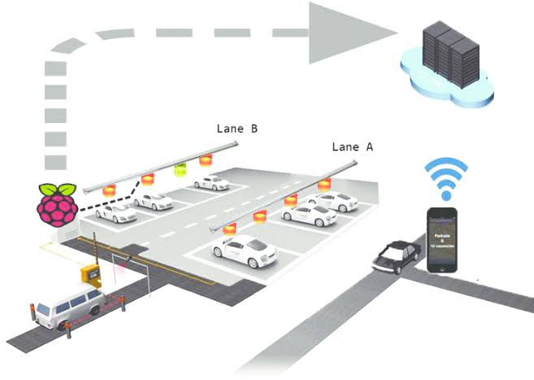
* Iot sensor can monitor parking infrastructure and send alerts when maintenance is needed, ensuring the safety and functionality of parking facilities.

Conclusion
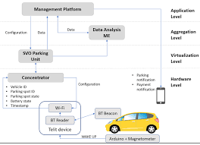
The implementation of smart parking systems using IoT (Internet of Things) technology offers numerous benefits, such as efficient space utilization, reduced traffic congestion, and improved user experience. However, the success of smart parking in IoT depends on several factors, including infrastructure, sensor accuracy, connectivity, and user adoption. In conclusion, smart parking in IoT has the potential to revolutionize urban mobility, it requires careful planning and investment to realize its full potential.

Project was carried out by:
- V . Dhivyasri (T.L )
- R . Dhanasekar
- P. Doss

